1.Write a hive query to find the minimum temperature observed in a given weather station in a particular year.

Here also we have implented hive statements to fetch the required data. For this to be achieved we have created table and loaded the dataset. Then to get minimum temperature from each weather station in a particular year we grouped by weather station and the year.

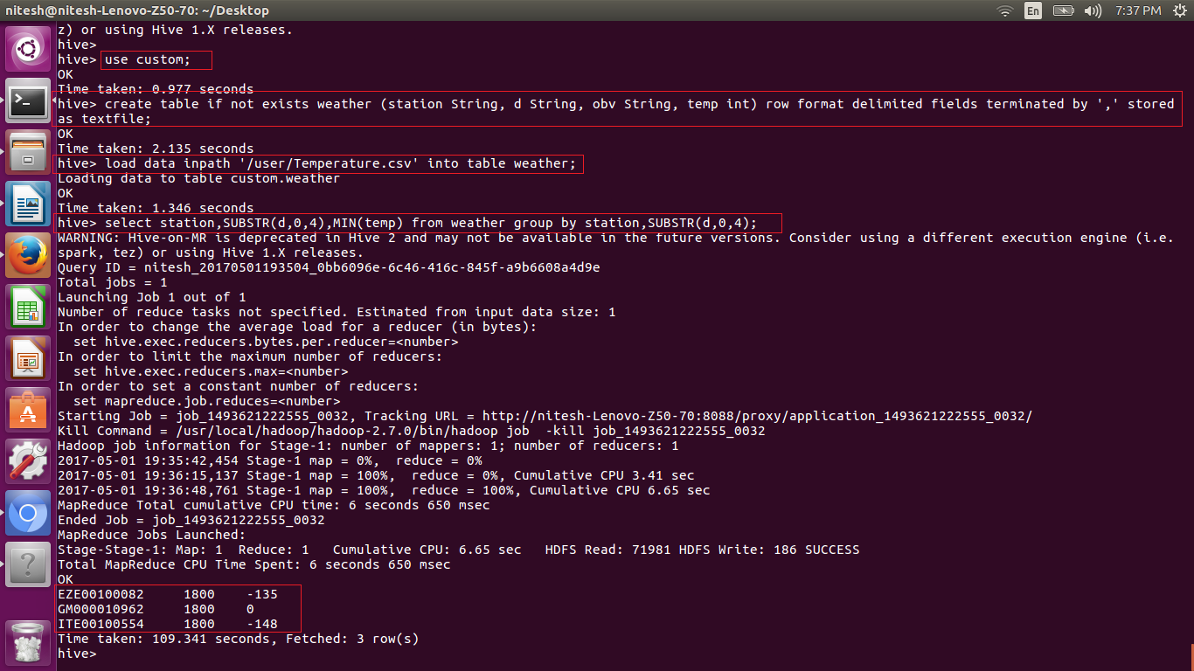

2. Write a hive query to find the maximum temperature observed in a given weather station in a particular year.

Here also we have implented hive statements to fetch the required data. For this to be achieved we have created table and loaded the dataset. Then to get maximum temperature from each weather station in a particular year we grouped by weather station and the year.

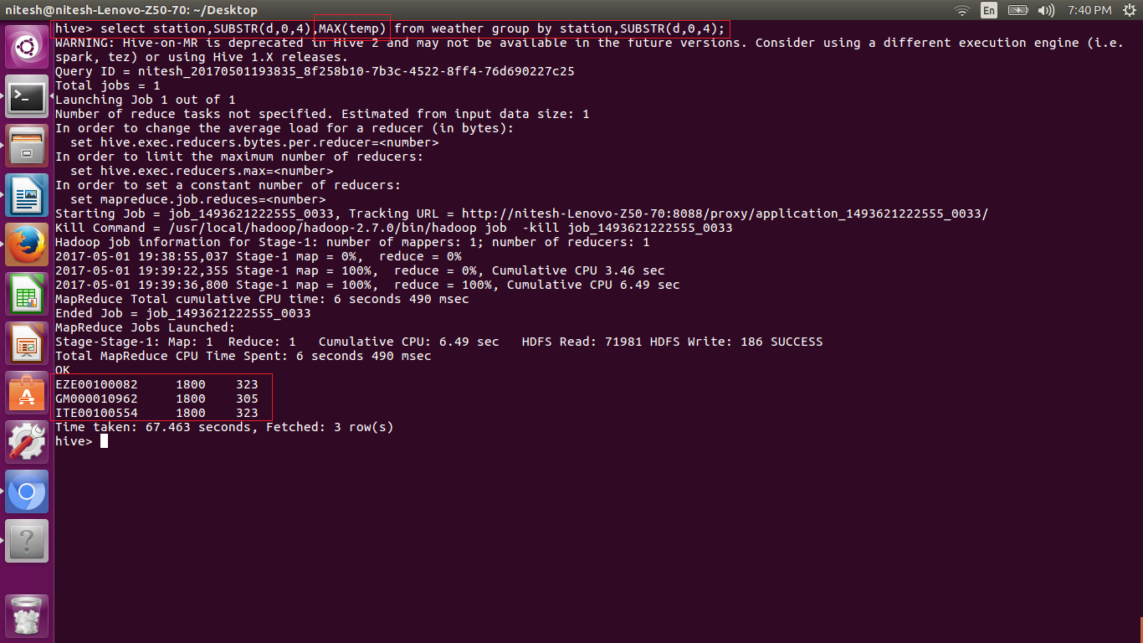

3. Write a hive query to find the number of readings given by each weather station according to the dataset.

Here we need to get the number of readings we have counted temp i.e. temperature column. And grouped using the station column to get the reading for each station.

